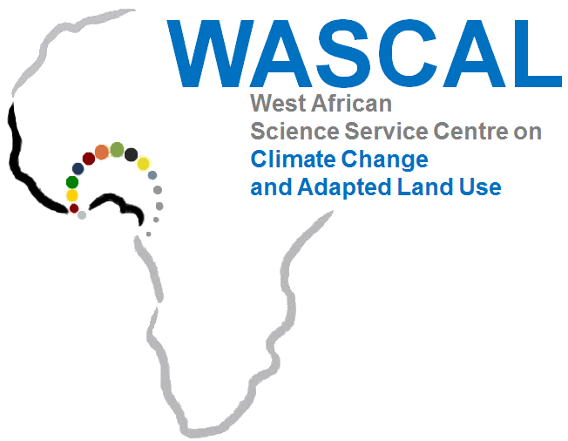

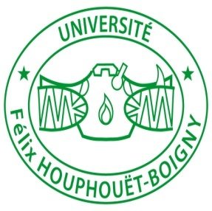Université Félix HOUPHOUET BOIGNY
Côte d’Ivoire

An International PhD Programme in Climate Change and Biodiversity

PHOTO
Network countries: Bénin, Burkina Faso, Cabo Verde, Côte d'Ivoire, Ghana, Mali, Niger, Nigeria, Senegal, The Gambia,and Togo

Application Form
PhD in Climate Change and Biodiversity
Université Félix HOUPHOUËT-BOIGNY
Côte d’Ivoire
1. Personal data
Last Name: ...................................................................................................................................
First Name(s): ..............................................................................................................................
Gender: .........................................................................................................................................
Date and place of birth: ...............................................................................................................
Nationality: ...................................................................................................................................
Marital status: ......................................Children: .......................................................................
Country of residence: ...................................................................................................................
Permanent address: .....................................................................................................................
Telephone number (compulsory): ...............................................................................................
Email address (compulsory): .......................................................................................................
P.O. Box: ......................................................................................................................................
Person to contact in Abidjan in case of emergency Name: ......................................................
Telephone number…............................Email address: .................................................................

2. University education
Universities  attended | Dates of attendance | Qualification obtained | Date qualification obtained  Title of degree awarded and grade

Higher degree:...............................................................................................................................................
Subject studied:............................................................................................................................................. Dissertation title: .........................................................................................................................................
........................................................................................................................................................................
.......................................................................................................................................................................
........................................................................................................................................................................
........................................................................................................................................................................

3. Language skills
Please indicate using abbreviation L, I or A (L=Low; I=Intermediate; A=Advanced)
Notation  Languages | Reading |  |  | Writing |  |  | Speaking
 | L | I | A | L | I | A | L | M | A
English
French
Other

4. Computer skills
 | Word | Excel | Power point | SPSS | CANOCO | Statistica | SPHINX | SPAD | Other
Beginner
Intermediate
Advanced

5. Employment record
Name and address of two previous employers (Please start with your most recent employment) | Dates of attendance | Position held

6. Letter of motivation
Personal statement should include the student’s academic and personal qualities as well as his or her interests in research in the area of Climate Change and Biodiversity.

7. Application supporting documents
- Completed application form
- Detailed CV
- Two references
- Letter of motivation
- Two passport photos
- Support letter from employer granting study leave (if employed)
- Transcripts of previous university degrees showing the grade of admission (Mention in French)
- Copy of birth certificate

I confirm to the best of my knowledge that the information given in this form is true.

Date:…………………………………………………………..Signature :……………………………
Start date of call for application: April 15, 2021
Deadline for applications : June 30, 2021

- Applicants should apply online (via link and email) to;
- Link: candidature.wascal-ci.org
- Email: skonate2@yahoo.fr and kouasedward@yahoo.fr
- and copy: capacitybp@wascal.org)
- Ineligible or incomplete application forms will not be processed
- Only successful applicants will be contacted

